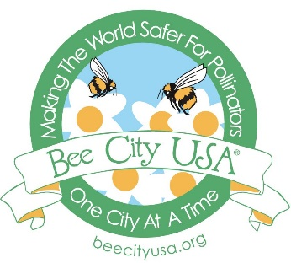
Bee Jamboree, Beeville, TX
Saturday, June 22, 2019
Vendor Application

Venue: Coastal Bend College, 3800 Charco Rd., Beeville, TX 78102
Date: Saturday, June 22, 2019
Time of event: 8a.m. – 1p.m
Set-up Time: 7a.m.
Vendor Fee: NO VENDOR FEE
Deadline: Friday 6/1419
---------------------------------------------------------------------
Dear Vendors,
We are excited about our third annual BEE JAMBOREE and look forward to a great event! Coastal Bend College has a beautiful campus with a walking trail and Pollinator Conservation Garden.
All vendors will set-up outside along the walking trail and parking lot area. There is no fee associated with being a vendor for this event, however you are required to bring your own tables, chairs & extension cords (if you need electricity).
Please fill out your information below and return to BeevilleMainStreet@BeevilleTx.org.

We will contact you prior to the event to let you know your exact set-up location.

Business Name: _____________________________________________________________
Address: __________________________________________________________________
Phone #:__________________________________________________________________
Contact Person: ____________________________________________________________
Email Address:_____________________________________________________________
Items displayed: ____________________________________________________________
Size of table or display: ______________________________________________________
Special Request: ____________________________________________________________
Tax Id# ___________________________________________________________________

Bee Jamboree, Beeville, TX
Vendor Application

Indemnity Agreement: In my capacity as a business owner/vendor for the City of Beeville, Mainstreet, Coastal Bend College & Bee County Chamber of Commerce, I acknowledge the risks, and assume personal responsibility for my actions. I hereby release, covenant not to sue and agree to indemnity and hold harmless the City of Beeville, and it’s agents, employees, officers, and successors from any claim or liability, which I, my heirs, executors, administrators may have or claim to have arising out of any bodily injury, death, or property damage/loss I might sustain relating to activities while participating in City of Beeville, Main Street Events or Markets. I understand that if I am a food or drink vendor, there are potential risks involved in cooking and/ or serving food or drink items which include, but are not limited to, burns, cuts, slipping, falling, or lifting heavy items that are actually heavier than they appear. I have read this Indemnity Agreement, Covenant Not to Sue and Liability Release, and I understand all its terms. I sign voluntarily and with full knowledge of its legal consequences.
Business Name: ________________________________________________________________

Printed Name: _________________________________________________________________

Signature: _____________________________________________________________________

Date: _________________________________________________________________________

If you have any questions, please contact Beeville Mainstreet at 361-358-4641 Ext 242.

