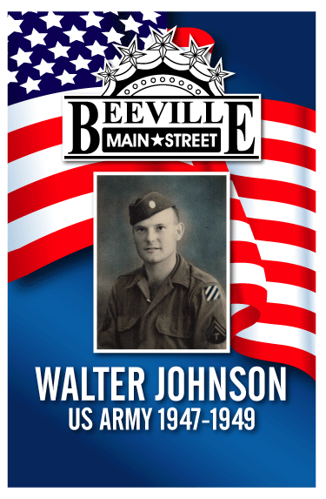
The banner will be utilized in downtown Beeville for Patriotic holidays. Open to all military branches of service and must be current or former resident of Beeville. The banner will remain with Beeville Main Street Program till the banner is ready to be retired and then will be made available to the family.
All information on this form must be completed fully. A 4 X 6”or larger military picture is requested. Size of banner is 24” X 37”. Cost is $60.00; banners will need to paid prior to processing.
Banner orders are placed in early spring & late summer. Ask Main Street for more information.
Full Name: ___________________________________________________
Military Branch: _______________________________________________
Dates Served: ________________________________________________

Name of Contact and Telephone Number:__________________________________________________

