Sasquatch! Bee County Bigfoot Forum
Vendors Application
Sunday, September 22nd 11:30am – 5:30pm; Setup opens at 10am.
John C. Fulghum Beeville Event Center
111 E. Corpus Christi St., Beeville.
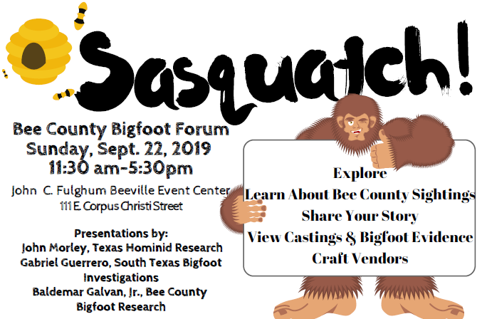
8x8 indoor space (16 booths), 1-8’ table & 2 chairs provided, AC, WIFI available, restrooms, electric outlets if needed inside. Outside space available also.

Business Name: ______________________________________________
Tax ID# ________________________ _____
Contact Name: ______________________________________________
Address: ______________________________________________
Phone #: ______________________________________________
E-mail: ______________________________________________
Description of items to be sold: _____ __________________________________________________________________________________
$25.00 per 8x8 inside space x spaces =
$15.00 per outside space
Need electric outlet (inside only):

Mail application with the liability release and check to:
Michelle Clark, 400 N. Washington Street, Beeville, TX 78102. Drop off Main Street Office, Beeville City Hall, 400 N. Washington Street. Contact: 361-542-8202
Make check payable to Michelle Clark.

Booth space on a first received payment basis. Limited space available.

Bigfoot Forum Vendor Rules:
- Electricity/power can be arranged by request on a limited basis inside only. Tables, chairs, tents, for outside vendors are the sole responsibility of the vendors.
- Each vendor is responsible for his or her own sales tax requirements.
- Vendors must keep their area clean and dispose of all trash in the dumpster outside. Bigfoot Forum is not responsible for trash disposal.
- Booths must be clearly and neatly marked with signage detailing the items for sale.
- All food booths must show proof of health/food permit.
- Absolutely no fireworks or poppers are allowed. No pins or nails on the walls.
- Absolutely no alcohol allowed on premises.
- In case of rain, severe or hazardous weather or any other act of God, there will be no reimbursement for booth fees.
- We encourage vendors to have fun! Decorate your booths, play music, and sell items that promote your business and items related to the topic of the forum.

Social Media Marketing Information such as pictures of items being sold, name of business and other relevant information you wish to share to promote Bigfoot Forum may be emailed to: Michelle.ClarkTrevino@BeevilleTx.org.

Sasquatch! Bee County Bigfoot Forum Event Indemnity Agreement, Covenant Not To Sue
and Liability Release.

In my capacity as a business owner/vendor for the Sasquatch! Bee County Bigfoot Forum, I acknowledge the risks, and assume personal responsibility for my actions. I hereby release, covenant not to sue and agree to indemnity and hold harmless the Michelle Clark, City of Beeville, Beeville Main Street, Bee County Bigfoot Forum, and it’s agents, employees, offices, and successors from any claim or liability, which I my heirs, executors, administrators may have or claim to have arising out of any bodily injury, death, or property damage/loss I might sustain relating to activities while participating in Bee County Bigfoot Forum. I understand that if I am a food or drink vendor, there are potential risks involved in cooking and/or serving food or drink items which include, but not limited to burns, cuts, slipping, falling, or lifting heavy items that are actually heavier than they appear. I have read this Indemnity Agreement, Covenant Not to Sue and Liability Release, and I understand all its terms.
I sign voluntarily and with full knowledge of its legal consequences.

Name of Vendor Business: __

Participant’s Signature and Date

